RESOLUTION NO.__________

RE: CERTIFICATE OF APPROPRIATENESS UNDER THE
PROVISIONS OF THE ACT OF THE PENNSYLVANIA
LEGISLATURE 1961, JUNE 13, P.L. 282 (53
SECTION 8004) AND BETHLEHEM ORDINANCE NO.
3952 AS AMENDED.

The applicant proposes install storm windows on approximately 23 windows
at 234 E. Market St.

NOW, THEREFORE, BE IT RESOLVED by the Council of the City of Bethlehem that a Certificate of Appropriateness is hereby granted for the proposal.

Sponsored by: (s)

(s)

ADOPTED BY COUNCIL THIS DAY OF

(s)
President of Council

ATTEST:

(s)
City Clerk

HISTORICAL & ARCHITECTURAL REVIEW BOARD

The applicant proposes install storm windows on approximately
23 windows at 234 E. Market St.

APPLICATION #1:

Frank & Beth Boyer
234 E. Market St.
Bethlehem, PA 18018

OWNER:

__________________________________________________________________________

The Board upon motion by Phil Roeder and seconded by Marsha Fritz adopted the proposal that City Council issue a Certificate of Appropriateness for the following:

- To install approximately 23 storm windows.

2. To be in almond color manufactured by Harvey Building Products.

3. To be full light storm windows with meeting rail matching the existing windows.

4. The motion was unanimously approved.

__________________________________________________________________________

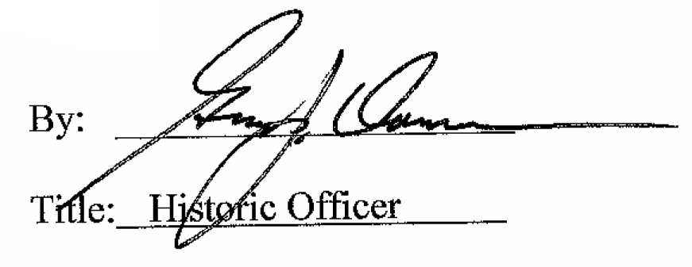

Date of Meeting: July 11, 2018

